**ABSTRACT**

Agriculture is the primary occupation in our country. India’s major income source is depending on agriculture therefore the development of agriculture is important. In today also most of the irrigation system are operated manually. The available traditional techniques are like drip irrigation, sprinkler irrigation etc. These techniques are need to be combined with IoT so that we can make use of water vary efficiently and also to control the Distribution System for Canal Irrigation System. IoT helps to access information and make major decision-making process by getting different values from sensors like soil moisture, water level sensors, water quality etc. This paper focuses primarily on reducing the wastage of water and minimizing the manual labor on field for irrigation so that you can saving time, cash and power of the farmer. And also Automate the Distribution System for Canal Irrigation System

**CHAPTER 1**

**INTRODUCTION**

**1.1 OVERVIEW**

Food production takes up almost half of the planets land surface. About 40% of the earth’s land is now given over to agriculture, and it consumes 85% of available fresh water. Due to globalization and population growth this ﬁgure of water conservation has been increasing every year. So it became a major challenge to every nation for reducing the farm water consumption. For better irrigation system, it is very crucial to measure the soil moisture for agriculture application, so that it will help farmers to manage their farm land more effectively.

Irrigation process should provide water to soil consistently when it is needed and stops water flow as well, when soil has soaked enough water. The excess of water in the crops is of no good, not only water is wasted but it also destroys crops. Considering Pakistan, whose economy is mainly based on agriculture requires efficient and modern methods for water provision in the crops fields. The failures caused through manual methods of irrigation has let us to think about some advance method which can be relied upon. Anything which is cost effective, labour saving and energy saving is considered efficient. In order to meritoriously reduce the impact of poor water resources on nation’s economy, since modern agricultural crop growing methodologies, existing engineering technologies and effective use of controlling skills appropriate consumption of water resources can be accomplished. Current research and implementation efforts are mostly oriented toward a traditional scenario with stationary sensors and single static sink that collect information from sensors where the sink is directly connected to the user or manager. The goal of this project is to present a fault tolerant, reliable, low latency and energy aware IOT based irrigation control system. Rendering to the elementary principles of Internet, with sensor technology, this project proposes precision agriculture irrigation systems based on the internet of things (IOT) technology, and focuses on reliable network architecture and software process control of the precision irrigation system. Primary tests revealed this structure is rational and realistic. This is also an approach for the advancement of irrigation process. With the advent of technology, the world around us is getting automated. Automatic systems are being chosen over manual structures, as they are energy efficient and minimize the need for tedious manual labor.

**1.2 BACKGROUND**

With agriculture being the primary economic sector of India and other developing countries, it is essential to automate it in order to increase efficiency. A typical farm requires a lot of labor. Automation can proficiently moderate the amount of manual labor, and make farming easier and faster, leading to more agricultural growth. Automation is the use of machines, control systems and information technologies to optimize productivity in the production of goods and delivery of services. Automation is the answer to India‘s pursuit for being a world-class industrial competitor. The Indian farms are slowly beginning to feel the stimulus for the instrumentation, control and automation industry. Indian automation is advancing at a fast pace, yet it is one area that can never be achieved and admired – it is something that needs constant innovation and identification of trends in technology, and the innovations that thrust the implementation of automation in other countries. India, as one of the world‘s fastest growing economies based on agriculture and farming, has not taken to technology at a rather quick pace. Internet of things and agricultural irrigation: India is known for the small farms. In India most of the crops depends upon rain. Near about 45% of the land irrigated. And almost half i.e. 55% of total population of India depends on agriculture .Comparing this with US; it is about 2% due of heavy mechanization of agriculture. The fact about Indian agriculture is that, though it is one of the biggest producers of agricultural products, other side it has very low farm productivity. Hence to increase the productivity is today‘s need and Precision agriculture may provide a way to do it. Precision agriculture (PA), as the name implies, refers to the application of precise and corrects amounts of inputs like water, fertilizers, pesticides etc. at the correct time to the crop for increasing its productivity and maximizing its yields. PA originated in the US and European countries. Gartner, the world‘s leading information technology research and advisory company, said, in December 2013, that IoT will grow to 26 billion units in 2020, resulting in 1.9$ trillion in global economic value-add through sales into diverse end markets. Hence the statement we can conclude that the IoT is evolving and that it will generate billions of dollars in the upcoming years. Similarly, Cisco also said that it will create, from 2013 to 2022, a 14.4$ Trillion of value at stake for companies and industry.Since we are talking about connecting everything to the Internet, there is an unimaginable amount of business opportunities involved. Industry, logistics and health are some of the sectors in which IoT is involved Because of this we can connect small objects or devices to the Internet, a whole new paradigm will emerge creating a big impact in people‘s lives. Intelligently connected appliances to the Internet, health-related devices collecting important data and wearable are just an example, and they are all trending. They will, definitely, deliver and improve our quality of life, making everything easier, practical, smarter and reliable. However, there is much work to be done in order for IoT to succeed and truly emerge: standards are needed to provide interoperability, security and confidentiality to protect individuals‘data must be implemented and scalability must also be possible. Without these parameters, IoT won‘t succeed and all we will ever have small ―islands of IoT, not communicating with each other and that truly is not Internet of Things.

**1.3 MOTIVATION**

According to statistics, agriculture uses 85% of available freshwater resources worldwide, and this percentage will continue to be dominant in water consumption because of population growth and increased food demand. There is an urgent need to create strategies based on science and technology for sustainable use of water, including technical, agronomic, managerial, and institutional improvements. Agricultural irrigation based on Internet technology is based on crop water requirement rules. By using Internet technology and sensor network technology to control water saving irrigation of farmland and to maximize the scientific use of water, not only can greatly improve the utilization of water, and can increase water productivity.

**1.4 OBJECTIVE OF OUR PROJECT**

* To develop system that automatically regulate the moisture of the soil.
* To minimize human labor used in irrigation
* To provide convenience in accessing the system from anywhere at any time.
* To save the time of the owner for the large fields.
* Monitoring Irrigation for multiple zone of a farmland.
* To display the soil moisture content on the web page using moisture sensors.
* To display the multiple zone on the web page.
* To remotely control the water supply, through web page using internet.
* To provide a provision for owner to water a specific zone of the farm.
* Automate Distribution System for Canal Irrigation System

**1.5 THESIS ORGANISATION**

Chapter 2 – Literature Survey, Discusses various related works

Chapter 3 – System Analysis, Provides a clear description of the existing methods and proposes system and its principle of operation

Chapter 4 – Hardware implementations, Gives the hardware details which are used in this project and there interfacing methodology

Chapter 5 – Software description, Disuses the software’s used for the development of the proposed system

Chapter 6 – Conclusion, Concluded the thesis with result and discussion

**CHAPTER 2**

**LITERATURE REVIEW**

R. Nageswara Rao et al proposed the method aims at making agriculture smart using automation and IoT technologies. Internet of Things (IoT) enables various applications crop growth monitoring and selection, irrigation decision support, etc. A Raspberry Pi based automatic irrigation IOT system is proposed to modernization and improves productivity of the crop. An efficient management of water should be developed and the system circuit complexity to be reduced. The proposed system developed on the information sent from the sensors and estimate the quantity of water needed. A two sensors are used to get the data to the base station the humidity and the temperature of the soil, the humidity, and the duration of sunshine per day.

Vaishali S et al presented an Automated irrigation system is essential for conservation of the water and indirectly viability of the farm since it is an important commodity. About 85% of total available water resources across the world are solely used for the irrigation purpose. In upcoming years this demand is likely to increase because of increasing population. To meet this demand we must adopt new techniques which will conserve need of water for irrigation process. In automation system water availability to crop is monitored through sensors and as per need watering is done through the controlled irrigation. The almost infinite capabilities of storage and processing, the rapid elasticity makes cloud computing an attractive solution to the large amount of data generated.

Shweta B. Saraf et al developed the smart objects embedded with sensors enables interaction with the physical and logical worlds according to the concept of IoT. In this paper proposed system is based on IoT that uses real time input data. Smart farm irrigation system uses android phone for remote monitoring and controlling of drips through wireless sensor network. Zigbee is used for communication between sensor nodes and base station. Real time sensed data handling and demonstration on the server is accomplished using web based java graphical user interface. Wireless monitoring of field irrigation system reduces human intervention and allows remote monitoring and controlling on android phone. Cloud Computing is an attractive solution to the large amount of data generated by the wireless sensor network.

Pradorn Sureephong et al investigates a prototyping of integrated system of Internet of Things based Wetting front detector (IOT-WFD) which focuses on how to enhance the IOT based Wetting front detector design for smart irrigation system. The empirical study was conducted with 2 sensors type to detect the wetting fronts which are the Frequency Domain Reflectrometry sensor (FDR) and Resistor-based sensor (RB) integrated and design with low-cost WFD. The results of this study point toward the IOT-WFD as an appropriated technology providing real time wetting front information in soil positively for application in terms of agricultural water management.

Dr Kamel Ammour et al present the possibility to control working and stopping of machines (composing a factory, an irrigation process and so on) controlled by a website via the internet from any place in the world. The idea is to send commands from a website to a factory (irrigation process) computer program control via a shared database in IoT environment. The attempt has shown very successful results both in a factory tar productivity for converting a panel board control to a computer program control and in a model irrigation system control from a website via a shared database.

M.MAHALAKSHMI et al presented the design and development of automated irrigation system powered by solar energy using Internet of Things (IoT). The project uses a Simple Link WI-Fi module (CC3200) which connects the hardware system to internet and it monitors PV system, controls the motor and solenoid valve for pumping water to the field on the statistics obtained from the water level sensor and soil moisture sensor. The entire system is overseen and governed by MQTT server (MQTT), which is an android app through internet. The main objective of the paper is to address the problem of water paucity and power dilemma by designing and implementing a smart irrigation system in the crop field.

ABINAYA et al developed the ongoing IOT research activities are directed towards the definition and design of standards and open architectures which is still have the issues requiring a global consensus before the final deployment. This paper gives over view about IOT technologies and applications related to agriculture with comparison of other survey papers and proposed a novel irrigation management system. Our main objective of this work is to for Farming where various new technologies to yield higher growth of the crops and their water supply.

Amogh Jayaraj Rau et al proposed the technology that is deployed in this field, we find that the development is not tremendous. After consulting with the Kerala Agricultural University, Mannuthy and Kerala Rice Research Station, Vytilla, we identified a few fundamental issues that are faced by the paddy farmers today. It includes the problem of over or under watering and the need for regular manual irrigation. Furthermore, when it comes to rice, which is the staple crop of Kerala, there does not exist a system for automatically monitoring the diseases associated with the rice species, and checking whether the crop is supplied with ample amount of nutrients.

Monica M et al presented the agricultural sector, an important sector of our economy accounts for a good percentage of our nation’s GDP and of the exports. With advancement in technology we can establish a system that automates the irrigation process such that there is efficient usage of water and create an ease of work load for the farmers. With embedded technology and Internet of Things, in this work we have designed IoT based automated irrigation system for the Indian scenario. Our system is able to deliver optimal water to the plants based on moisture, light and temperature levels which are obtained through sensors.

Kiranmai Pernapati et al presents the old irrigation system which demands a lot of water, so it needs smart techniques for reducing the percentage of wasting available water for the irrigation. We have been seeing the increasing of huge demand for Internet of things in every domain from small and simple applications to large and complex applications. Practically implementation of a Smart Irrigation is very complex deal, but association with IoT using Smart wireless sensors it brings a great management system. The Humidity and Temperature Sensor sense the both water vapor content and temperature around the plant.

**CHAPTER 3**

**SYSTEM ANALYSIS**

**3.1 OVERVIEW**

Smart irrigation systems offer a variety of advantages over traditional irrigation systems. Smart irrigation systems can optimize water levels based on things such as soil moisture and Automate the Distribution System for Canal Irrigation System. This is done with wireless moisture sensors that communicate with the smart irrigation controls and help inform the system whether or not the landscape is in need of water. Additionally, the smart irrigation controlled receives local weather data that can help it determine when a landscape should be watered. The Smart Irrigation System is an IoT based device which is capable of automating the irrigation process by analyzing the moisture of soil and the climate condition (like raining).Also the data of sensors will be displayed in graphical form on BOLT cloud page. The advantages of these smart irrigation systems are wide reaching. The smart irrigation system will help you have better control of your landscape and irrigation needs as well as peace of mind that the smart system can make decisions independently if you are away. You will save a significant amount of money on your water bills because through intelligent control and automation, your smart irrigation system will optimize resources so that everything gets what it needs without needless waste. Additionally, we have all seen many places in the country that have experienced droughts and we know that our water resources are precious. With smart irrigation systems we can be better stewards of our resources which is better for the environment. The opportunity to save dramatically, have better control and be more eco-friendly while maintaining a lush and beautiful landscape are just a few of the advantages a smart irrigation system provides and would make a wonderful addition to any home. Smart Irrigation System uses valves to turn irrigation ON and OFF. These valves may be easily automated by using controllers and solenoids. Automating farm or nursery irrigation allows farmers to apply the right amount of water at the right time, regardless of the availability of labour to turn valves on and off. Benefits of Smart Irrigation are

• Save water and money

• Save your customers money

• Make maintaining yard easy and convenient

• Minimize the infrastructure to store and carry water

• Protect the water resources for future generations

This project proposes irrigation system which describes the combination of the IoT communication technology and cloud server to accomplish performance of system and data storage. The proposed system provides remote monitoring and automated controlling of irrigation with real time sensing of atmospheric and soil conditions like air temperature, humidity and soil moisture. IoT based irrigation improves farm production without any human interloping.

The proposed system is automatic irrigation system. The automaticity means that it turns itself on and off depending upon the soil moisture requirement. This automatic behavior of irrigation is achieved using different sensors which sense and tell the user if water is required or not and how much water will be enough for soil so that water wastage is also avoided. The errors which may arise when manual irrigation is used are also rectified for the most part using this method. And also Automate the Distribution System for Canal Irrigation System

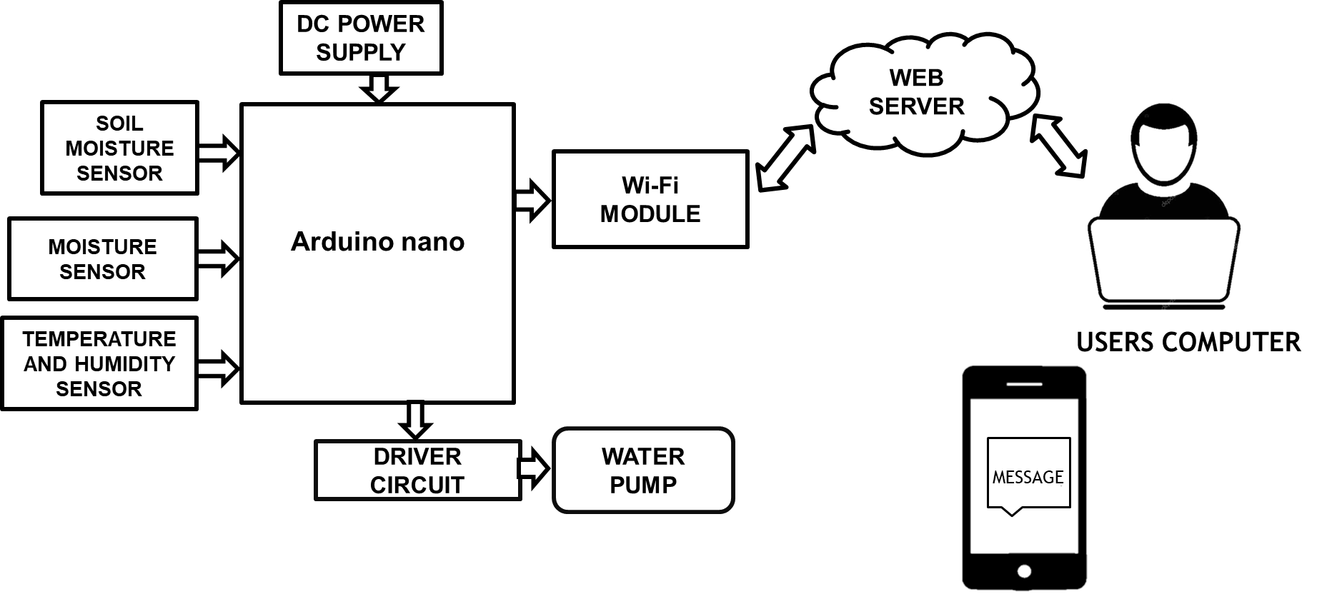

Figure.3.1. Smart irrigation system

**Canal Irrigation System**

A canal is an artificial channel that is constructed to carry water to the fields to perform irrigation. The water is taken either from the river, tank or reservoirs. The canals can be constructed either by means of concrete, stone, brick or any sort of flexible membrane which solves the durability issues like seepage and erosion.

## Distribution System for Canal Irrigation System

Whatever be the irrigation scheme i.e direct irrigation using weir or a barrage and storage irrigation scheme like dams or reservoir, both demand a network of irrigation canals of various sizes and capacities.

**3.2 METHODOLOGY**

The main working principle behind this system is in

connecting the soil moisture sensor, which was previously

embedded into the plant, to the Arduino microcontroller,

which is also connected to other electronic components

listed above as shown in Figure 1. Measurement of soil

moisture is done by the sensor which forwards the infor-

mation and parameters regarding the soil moisture to the

microcontroller, which controls the pump. If the level of

soil moisture drops below a certain value, the microcon-

troller sends the signal to the relay module which then

runs a pump and certain amount of water is delivered to

the plant. Once the enough water is delivered, the pump

stops doing its work. Power supply has a task to power the

complete system and the recommended voltage should re-

spect the input supply range for the microcontroller, that

is, from 7V to 12V. Relay module is a simple circuit con-

sisting of a single transistor, several resistors, diodes and

a relay and it is controlled digitally by microcontroller.

Since t he complete system should be embedded i n a small

box, Arduino Nano is a perfect microcontroller for this

purpose because of its dimensions and its work perfor-

mance. Soil moisture module is consisting of the two parts:

ampliﬁ er circuit and probes. This module has digital and

analog outputs, where digital output is set to logical 1

when the threshold is activated. The threshold is set by

potentiomet er. Ana log output gives the rea l t ime i nforma-

tion regarding the moisture in the plant and this output

is used in the system. Water pump is connected to the

relay module and it only works when the relay module gets

a command from the microcontroller,

The main working principle behind this system is in

connecting the soil moisture sensor, which was previously

embedded into the plant, to the Arduino microcontroller,

which is also connected to other electronic components

listed above as shown in Figure 1. Measurement of soil

moisture is done by the sensor which forwards the infor-

mation and parameters regarding the soil moisture to the

microcontroller, which controls the pump. If the level of

soil moisture drops below a certain value, the microcon-

troller sends the signal to the relay module which then

runs a pump and certain amount of water is delivered to

the plant. Once the enough water is delivered, the pump

stops doing its work. Power supply has a task to power the

complete system and the recommended voltage should re-

spect the input supply range for the microcontroller, that

is, from 7V to 12V. Relay module is a simple circuit con-

sisting of a single transistor, several resistors, diodes and

a relay and it is controlled digitally by microcontroller.

Since t he complete system should be embedded i n a small

box, Arduino Nano is a perfect microcontroller for this

purpose because of its dimensions and its work perfor-

mance. Soil moisture module is consisting of the two parts:

ampliﬁ er circuit and probes. This module has digital and

analog outputs, where digital output is set to logical 1

when the threshold is activated. The threshold is set by

potentiomet er. Ana log output gives the rea l t ime i nforma-

tion regarding the moisture in the plant and this output

is used in the system. Water pump is connected to the

relay module and it only works when the relay module gets

a command from the microcontroller,

The main working principle behind this system is in

connecting the soil moisture sensor, which was previously

embedded into the plant, to the Arduino microcontroller,

which is also connected to other electronic components

listed above as shown in Figure 1. Measurement of soil

moisture is done by the sensor which forwards the infor-

mation and parameters regarding the soil moisture to the

microcontroller, which controls the pump. If the level of

soil moisture drops below a certain value, the microcon-

troller sends the signal to the relay module which then

runs a pump and certain amount of water is delivered to

the plant. Once the enough water is delivered, the pump

stops doing its work. Power supply has a task to power the

complete system and the recommended voltage should re-

spect the input supply range for the microcontroller, that

is, from 7V to 12V. Relay module is a simple circuit con-

sisting of a single transistor, several resistors, diodes and

a relay and it is controlled digitally by microcontroller.

Since t he complete system should be embedded i n a small

box, Arduino Nano is a perfect microcontroller for this

purpose because of its dimensions and its work perfor-

mance. Soil moisture module is consisting of the two parts:

ampliﬁ er circuit and probes. This module has digital and

analog outputs, where digital output is set to logical 1

when the threshold is activated. The threshold is set by

potentiomet er. Ana log output gives the rea l t ime i nforma-

tion regarding the moisture in the plant and this output

is used in the system. Water pump is connected to the

relay module and it only works when the relay module gets

a command from the microcontroller,

The main working principle behind this system is in

connecting the soil moisture sensor, which was previously

embedded into the plant, to the Arduino microcontroller,

which is also connected to other electronic components

listed above as shown in Figure 1. Measurement of soil

moisture is done by the sensor which forwards the infor-

mation and parameters regarding the soil moisture to the

microcontroller, which controls the pump. If the level of

soil moisture drops below a certain value, the microcon-

troller sends the signal to the relay module which then

runs a pump and certain amount of water is delivered to

the plant. Once the enough water is delivered, the pump

stops doing its work. Power supply has a task to power the

complete system and the recommended voltage should re-

spect the input supply range for the microcontroller, that

is, from 7V to 12V. Relay module is a simple circuit con-

sisting of a single transistor, several resistors, diodes and

a relay and it is controlled digitally by microcontroller.

Since t he complete system should be embedded i n a small

box, Arduino Nano is a perfect microcontroller for this

purpose because of its dimensions and its work perfor-

mance. Soil moisture module is consisting of the two parts:

ampliﬁ er circuit and probes. This module has digital and

analog outputs, where digital output is set to logical 1

when the threshold is activated. The threshold is set by

potentiomet er. Ana log output gives the rea l t ime i nforma-

tion regarding the moisture in the plant and this output

is used in the system. Water pump is connected to the

relay module and it only works when the relay module gets

a command from the microcontroller,

Our project uses home‘s installed irrigation system as the initial platform. It has several zones that are controlled by a controller installed in the basement. System block diagram, which shows the basic system components. This system is relatively uncomplicated wherein the controller operates water solenoids connected to individual zones. Only one zone in this system can be activated as home water supply volume will not support operating more than one zone.

The main working principle behind this system is in connecting the soil moisture sensor, which was previously embedded into the plant, to the Arduino microcontroller, which is also connected to other electronic components. Measurement of soil moisture is done by the sensor which forwards the information and parameters regarding the soil moisture to the microcontroller, which controls the pump. And also Automate the Distribution System for Canal Irrigation System. If the level of soil moisture drops below a certain value, the microcontroller sends the signal to the relay module which then runs a pump and certain amount of water is delivered to the plant. Once the enough water is delivered, the pump stops doing its work. Power supply has a task to power the complete system and the recommended voltage should respect the input supply range for the microcontroller, that is, from 7V to 12V.

Relay module is a simple circuit consisting of a single transistor, several resistors, diodes and a relay and it is controlled digitally by microcontroller. Since the complete system should be embedded in a small box, Arduino Nano is a perfect microcontroller for this purpose because of its dimensions and its work performance. Soil moisture module is consisting of the two parts: ampliﬁer circuit and probes. This module has digital and analog outputs, where digital output is set to logical 1 when the threshold is activated. The threshold is set by potentiometer. Analog output gives the real time information regarding the moisture in the plant and this output is used in the system. Water pump is connected to the relay module and it only works when the relay module gets a command from the microcontroller, and also Automate the Distribution System for Canal Irrigation System

**CHAPTER 4**

**HARDWARE IMPLEMENTATION**

**4.1 POWER SUPPLY**

There are many types of power supply. Most are designed to convert the Voltage AC Mains electricity to a suitable low voltage supply for electronic Circuits and other Devices. A power supply can by broken down into a series of blocks, each of which performs a particular function. Here the AC supply main is given to the step down transformer. The transformer having the different voltages.

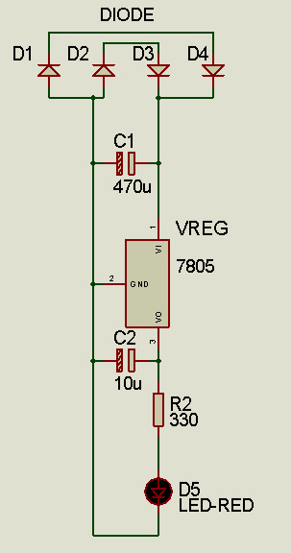

Figure 4.1: Circuit Diagram of Regulated Power Supply

The output from the transformer is given to the rectifier circuit. In this rectifier circuit the AC voltage is converted to DC voltages. The rectified DC voltage is given to the regulator circuit. The output of the regulator is depends upon the regulator IC chosen in the circuit.

**4.1.1 BRIDGE RECTIFIER**

A bridge rectifier can be made using four individual diodes, but it is also available in special packages containing the four diodes required. It is called a full-wave rectifier. Smoothing is performed by a large value electrolytic capacitor connected across the DC Supply to act as a reservoir, supplying current to the output when the varying DC Voltage from the rectifier is falling

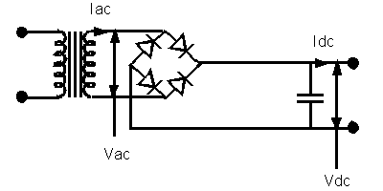

Figure 4.2: Bridge Rectifier

The fig 4.2 shows the unsmoothed DC, smoothed DC by the filter capacitors. The capacitor charges quickly near the Peak of the varying DC, and then discharges as it supplies current to the output.

Note that smoothing significantly increases the average DC voltage to almost the peak Value (1.4-× RMS value). For example, 6V RMS AC is rectified to full wave DC of about 4.6V RMS (1.4V is lost in the bridge rectifier), with smoothing this increases to almost The peak value giving 1.4 × 4.6 = 6.4V smooth DC. Smoothing is not perfect due to the capacitor voltage falling a little as it discharges, Giving a small ripple voltage. For many circuits a ripple which is 10% of the supply Voltage is satisfactory and the equation below gives the required value for the Smoothing capacitor. A larger capacitor will give less ripple. The capacitor value must Be doubled when smoothing half-wave DC.

**4.1.2 REGULATOR**

Voltage regulators ICs are available with fixed (typically 5, 12 and 15V) or variable Output voltages. They are also rated by the maximum current they can pass. Negative Voltage regulators are available, mainly for use in dual supplies. Most regulators include some automatic protection from excessive current ('overload protection') and Overheating ('thermal protection').

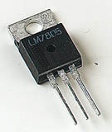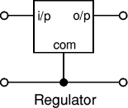

Figure 4.3(a): Regulator Figure 4.3(b): Regulator IC

Many of the fixed voltage regulator ICs has 4 leads and look like power transistors, Such as the 7805 +5V 1A regulator shown on the right. They include a hole for attaching a heat sink if necessary.

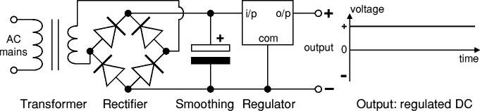

Figure 4.4: Rectifier Circuit Diagram and Waveform

The above fig 4.4 shows the rectifier circuit diagram and the regulated output voltage. The regulated DC output is very smooth with no ripple. In generally there are two types of regulators are used. Namely the positive and negative type regulators. For positive type regulators 78** series of regulators are used. For negative type regulators 79** series of regulators are used. Depends upon the voltage and type of the voltage the regulator IC is selected.

**4.2 NODEMCU**

The NodeMcu is an open-source firmware and development kit that helps you to Prototype your IOT product within a few Lua script lines.

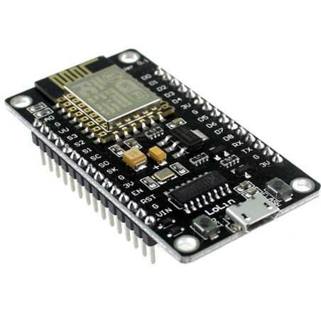

Figure 4.5 NodeMcu

The NodeMCU (Node MicroController Unit) is an open source software and hardware development environment that is built around a very inexpensive System-on-a-Chip (SoC) called the ESP8266. The ESP8266 is designed and manufactured by Express, contains all crucial elements of the modern computer: CPU, RAM, networking (wi-fi), and even a modern operating system and SDK. When purchased at bulk, the ESP8266 chip costs only $2 USD a piece. That makes it an excellent choice for this system design.

The NodeMCU aims to simplify ESP8266 development. It has two key components.

* An open source ESP8266 firmware that is built on top of the chip manufacturer's proprietary SDK. The firmware provides a simple programming environment based on eLua (embedded Lua), which is a very simple and fast scripting language with an established developer community. For new comers, the Lua scripting language is easy to learn. And to add on NodeMCU can be programmed with the Android IDE too.
* A development kit board that incorporates the ESP8266 chip on a standard circuit board. The board has a built-in USB port that is already wired up with the chip, a hardware reset button, Wi-Fi antenna, LED lights, and standard-sized GPIO (General Purpose Input Output) pins that can plug into a bread board.

**4.2.1DESCRIPTION:**

The ESP8266 WiFi Module is a self-contained SOC with integrated TCP/IP protocol stack that can give any microcontroller access to your WiFi network. The ESP8266 is capable of either hosting an application or offloading all Wi-Fi networking functions from another application processor. Each ESP8266 module comes pre-programmed with an AT command set firmware, meaning, you can simply hook this up to your Arduino device and get about as much WiFi-ability as a WiFi Shield offers (and that’s just out of the box).The ESP8266 module is an extremely cost effective board with a huge, and ever growing, community.

This module has a powerful enough on-board processing and storage capability that allows it to be integrated with the sensors and other application specific devices through its GPIOs with minimal development up-front and minimal loading during runtime. Its high degree of on-chip integration allows for minimal external circuitry, including the front-end module, is designed to occupy minimal PCB area. The ESP8266 supports APSD for VoIP applications and Bluetooth co-existance interfaces, it contains a self-calibrated RF allowing it to work under all operating conditions, and requires no external RF parts. There is an almost limitless fountain of information available for the ESP8266, all of which has been provided by amazing community support. In the Documents section below you will find many resources to aid you in using the ESP8266, even instructions on how to transforming this module into an IoT.

* NodeMCU is an open source IoT platform. Which includes firmware which runs on the ESP8266 Wi-Fi Module from Espressif Systems,and hardware which is based on the ESP-12 module.

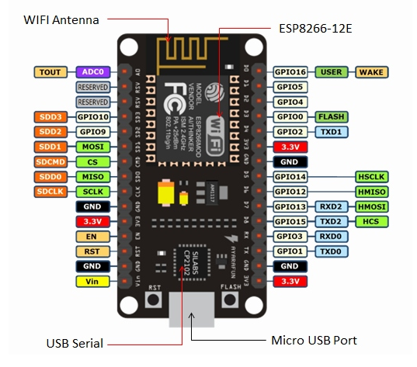

Figure 4.6 Node MCU Pin diagram

* The term “NodeMCU” by default refers to the firmware rather than the dev kits. NodeMCU firmware was developed so that AT commands can be replaced with Lua scripting making the life of developers easier. So it would be redundant to use AT commands again in NodeMCU.
* The ESP8266 is a low-cost Wi-Fi chip with full TCP/IP stack and microcontroller capability

**Features:**

* Open-source
* Interactive
* Programmable
* Low cost
* Simple
* Smart
* WI-FI enabled

**4.3 ARDUINO**

[Arduino](http://arduino.cc/) is an open-source platform used for building electronics projects. Arduino consists of both a physical programmable circuit board (often referred to as a [microcontroller](http://en.wikipedia.org/wiki/Microcontroller)) and a piece of [software](http://arduino.cc/en/Main/Software), or IDE (Integrated Development Environment) that runs on your computer, used to write and upload computer code to the physical board. The Arduino platform has become quite popular with people just starting out with electronics, and for good reason. Unlike most previous programmable circuit boards, the Arduino does not need a separate piece of hardware (called a programmer) in order to load new code onto the board – you can simply use a USB cable. Additionally, the Arduino IDE uses a simplified version of C++, making it easier to learn to program. Finally, Arduino provides a standard form factor that breaks out the functions of the micro-controller into a more accessible package.

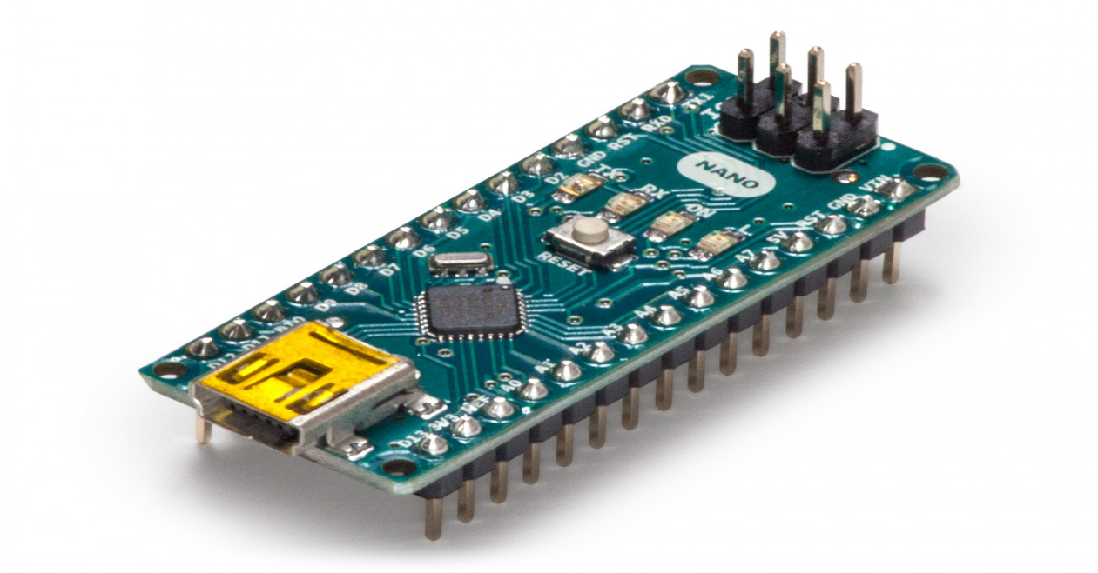

Figure 4.7 Arduino nano

|  |  |
| --- | --- |
| **Microcontroller** | **ATmega428** |
| **Operating Voltage** | 5V |
| **Input Voltage (recommended)** | 7-12V |
| **Input Voltage (limits)** | 6-20V |
| **Digital I/O Pins** | 14 (of which 6 provide PWM output) |
| **Analog Input Pins** | 6 |
| **DC Current per I/O Pin** | 40 mA |
| **DC Current for 4.4V Pin** | 50 Ma |
| **Flash Memory** | 42 KB (ATmega428) of which 0.5 KB used by boot loader |
| **SRAM** | 2 KB (ATmega428) |
| **EEPROM** | 1 KB (ATmega428) |
| **Clock Speed** | 16 MHz |

Table 1.1: Arduino Summery

**4.3.1 ARDUINO nano PIN DIAGRAM**

A typical example of Arduino board is Arduino nano. It consists of ATmega428- a 28 pin microcontroller. Arduino nano consists of 14 digital input/output pins (of which 6 can be used as PWM outputs), 6 analog inputs, a 16 MHz crystal oscillator, a USB connection, a power jack, an ICSP header, and a reset button

**Power (Usb / Barrel Jack)**

Arduino can be power either from the pc through a USB or through external source like adaptor or a battery. It can operate on a external supply of 7 to 12V. Power can be applied externally through the pin Vin or by giving voltage reference through the IORef pin..In the picture above the USB connection is labeled **(1)** and the barrel jack is labeled **(2)**.The USB connection is also how you will load code onto your Arduino board. The recommended voltage for most Arduino models is between 6 and 12 Volts.

**Pins (5v, 4.4v, Gnd, Analog, Digital, Pwm, Aref)**

The pins on your Arduino are the places where you connect wires to construct a circuit probably in conjunction with a [breadboard](https://learn.sparkfun.com/tutorials/how-to-use-a-breadboard/) and some [wire](https://learn.sparkfun.com/tutorials/working-with-wire). They usually have black plastic ‘headers’ that allow you to just plug a wire right into the board. The Arduino has several different kinds of pins, each of which is labeled on the board and used for different functions.

* **GND** : Short for ‘Ground’. There are several GND pins on the Arduino, any of which can be used to ground your circuit.
* **5V & 4.4V** : As you might guess, the 5V pin supplies 5 volts of power, and the 4.4V pin supplies 4.4 volts of power. Most of the simple components used with the Arduino run happily off of 5 or 4.4 volts.
* **Analog (5)**: The area of pins under the ‘Analog In’ label (A0 through A5 on the UNO) are Analog In pins. These pins can read the signal from an analog sensor (like a [temperature sensor](https://www.sparkfun.com/products/10988)) and convert it into a digital value that we can read.
* **Digital (4)**: Across from the analog pins are the digital pins (0 through 14 on the UNO). These pins can be used for both digital input (like telling if a button is pushed) and digital output (like powering an LED).
* **PWM** : You may have noticed the tilde (~) next to some of the digital pins (4, 5, 6, 9, 10, and 11 on the UNO). These pins act as normal digital pins, but can also be used for something called Pulse-Width Modulation (PWM). We have [a tutorial on PWM](https://learn.sparkfun.com/tutorials/pulse-width-modulation), but for now, think of these pins as being able to simulate analog output (like fading an LED in and out).
* **AREF** : Stands for Analog Reference. Most of the time you can leave this pin alone. It is sometimes used to set an external reference voltage (between 0 and 5 Volts) as the upper limit for the analog input pins.

**Reset Button**

Just like the original Nintendo, the Arduino has a reset button **(7)**. Pushing it will temporarily connect the reset pin to ground and restart any code that is loaded on the Arduino. This can be very useful if your code doesn’t repeat, but you want to test it multiple times. Unlike the original Nintendo however, blowing on the Arduino doesn’t usually fix any problems.

**Power Led Indicator**

Just beneath and to the right of the word “UNO” on your circuit board, there’s a tiny LED next to the word ‘ON’ . This LED should light up whenever you plug your Arduino into a power source. If this light doesn’t turn on, there’s a good chance something is wrong. Time to re-check your circuit!

**TX RX LEDS**

TX is short for transmit, RX is short for receive. These markings appear quite a bit in electronics to indicate the pins responsible for [serial communication](https://learn.sparkfun.com/tutorials/serial-communication). In our case, there are two places on the Arduino nano where TX and RX appear – once by digital pins 0 and 1, and a second time next to the TX and RX indicator LEDs **(12)**. These LEDs will give us some nice visual indications whenever our Arduino is receiving or transmitting data (like when we’re loading a new program onto the board).

**Main Ic AT mega328p**

Think of it as the brains of our Arduino. The main IC on the Arduino is slightly different from board type to board type, but is usually from the AT mega line of IC’s from the ATMEL company. This can be important, as you may need to know the IC type (along with your board type) before loading up a new program from the Arduino software. This information can usually be found in writing on the top side of the IC. If you want to know more about the difference between various IC’s, reading the datasheets is often a good idea.

**Voltage Regulator**

The voltage regulator **(4)** is not actually something you can (or should) interact with on the Arduino. But it is potentially useful to know that it is there and what it’s for. The voltage regulator does exactly what it says – it controls the amount of voltage that is let into the Arduino board. Think of it as a kind of gatekeeper; it will turn away an extra voltage that might harm the circuit. Of course, it has its limits, so don’t hook up your Arduino to anything greater than 20 volts**.**

**4.4 DH11 TEMPERATURE SENSOR**

The DHT11 is a basic, low cost digital temperature and humidity sensor.

* DHT11 is a single wire digital humidity and temperature sensor, which provides humidity and temperature values serially with one-wire protocol.
* DHT11 sensor provides relative humidity value in percentage (20 to 90% RH) and temperature values in degree Celsius (0 to 50 °C).
* DHT11 sensor uses resistive humidity measurement component, and NTC temperature measurement component.

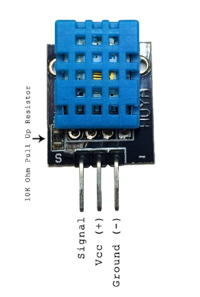

Figure 4.9 DH11 sensor module

The DHT11 sensors have four pins, VCC, GND, the data pin and a not connected pin which has no usage. A pull-up resistor from 5K to 10K Ohms is required to keep the data line high and in order to enable the communication between the sensor and

the NodeMCU board. There are some versions of these sensors that come with breakout boards with the built-in pull-up resistor and they have just 3 pins. We will be using the one with 3 pins and a 10K Ohm Resistor.

**4.4.1 CONNECTION OF DH11 WITH NODEMCU**

The DHT11 (or DHT22 and similar) are cheap temperature and humidity sensors. The communicate with a ESP8266 is over a single wire, but unfortunately it is not compatible with the 1-Wire protocol defined by Dallas Semiconductors. The electric connection to the NodeMCU is very simple, as the DHT series can be powered direct with 3.3V. Only 3 wires are needed: VCC, GND and the data line.The above figure shows the connection diagram of the sensor with nodeMCU were thee data pin is connected to GPIO D1 of the NodeMCU. The Vcc connected to Vin and GND to ground of the 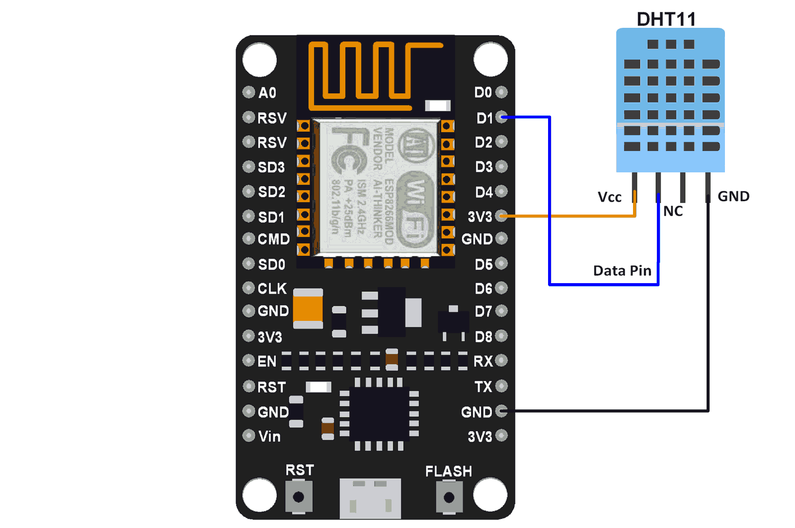NodeMCU

Figure 4.10 connection of DH11 sensor with NodeMCU 12E module

**4.5 SOIL MOISTURE SENSOR**

This sensor can be used to test the moisture of soil, when the soil is having water shortage, the module output is at high level, else the output is at low level. By using this sensor one can automatically water the flower plant, or any other plants requiring automatic watering technique. Module triple output mode, digital output is simple, analog output more accurate, serial output with exact readings.

The Soil Moisture Sensor uses capacitance to measure dielectric permittivity of the surrounding medium. In soil, dielectric permittivity is a function of water content. The sensor creates a voltage proportional to the dielectric permittivity, and therefore the water content of the soil. The sensor averages the water content over the entire length of the sensor. There is a 2 cm zone of influence with respect to the flat surface of the sensor, but it has little or no sensitivity at the extreme edges.

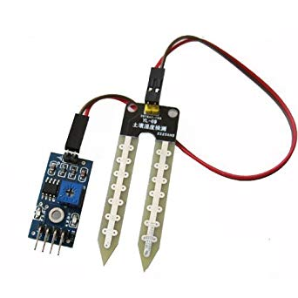

Figure 4.11 Soil Moisture Sensor

**Features**

* Sensitivity adjustable.
* Has fixed bolt whole, convenient installation.
* Threshold level can be configured.
* Module triple output mode, digital output is simple, analog output more
* Accurate, serial output with exact readings.

**Applications**

* Agriculture
* Landscape irrigation

**Using the Sensor**

* Connect +5v to pin 2 and ground to pin 5 and 6.
* Pin 4 and 5 should be connected to particular transmitter and receiver pin of controller.
* Output pin may be connected to any port pins and can be used to any application.

**4.5.1 INTERFACING OF MOISTURE SENSOR**

Soil moisture sensors measure the water content in soil. A soil moisture probe is made up of multiple soil moisture sensors. One common type of soil moisture sensors in commercial use is a Frequency domain sensor such as a capacitance sensor. Another sensor, the neutron moisture gauge, utilize the moderator properties of water for neutrons.

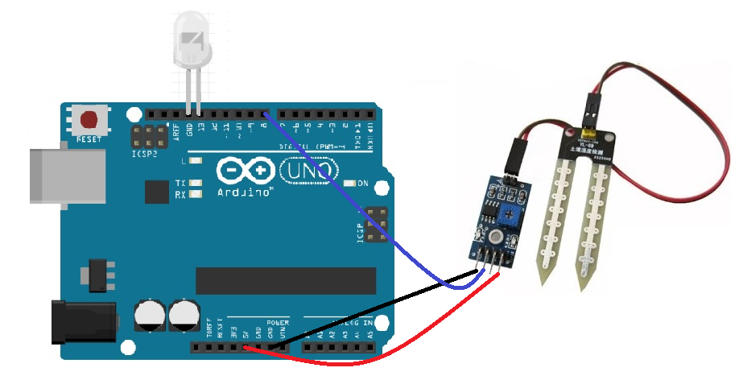

Figure .4.12 Arduino Interfacing of Soil Moisture Sensor

Soil moisture content may be determined via its effect on dielectric constant by measuring the capacitance between two electrodes implanted in the soil. Where soil moisture is predominantly in the form of free water (e.g., in sandy soils), the dielectric constant is directly proportional to the moisture content. The probe is normally given a frequency excitation to permit measurement of the dielectric constant. The readout from the probe is not linear with water content and is influenced by soil type and soil temperature. Therefore, careful calibration is required and long-term stability of the calibration is questionable.

* In This sensor We are using 2 Probes to be dipped into the Soil
* As per Moisture We will get Analoug Output variations from 0.60volts -5volts
* Input Voltage 5V DC

**4.6 RELAY**

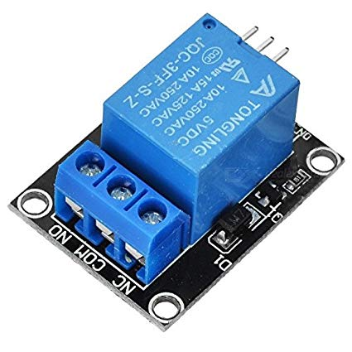Relay is an electromagnetic device which is used to isolate two circuits electrically and connect them magnetically. They are very useful devices and allow one circuit to switch another one while they are completely separate. They are often used to interface an electronic circuit (working at a low voltage) to an electrical circuit which works at very high voltage. For example, a relay can make a 5V DC battery circuit to switch a 230V AC mains circuit.

Figure 4.13 Relay module

**4.6.1 WORKING OF A RELAY**

A relay switch can be divided into two parts: input and output. The input section has a coil which generates magnetic field when a small voltage from an electronic circuit is applied to it. This voltage is called the operating voltage. Commonly used relays are available in different configuration of operating voltages like 6V, 9V, 12V, 24V etc. The output section consists of contactors which connect or disconnect mechanically. In a basic relay there are three contactors: normally open (NO), normally closed (NC) and common (COM). At no input state, the COM is connected to NC. When the operating voltage is applied the relay coil gets energized and the COM changes contact to NO. Different relay configurations are available like SPST, SPDT, and DPDT etc, which have different number of changeover contacts. By using proper combination of contactors, the electrical circuit can be switched on and off. Get inner details about structure of a relay switch.

The COM terminal is the common terminal. If the COIL terminals are energized with the rated voltage, the COM and the NO terminals have continuity. If the COIL terminals are not energized, then the COM and the NO terminals have no continuity.

The NC terminal is the Normally Closed terminal. It is the terminal that can be powered on even if the relay doesn't receive any or sufficient voltage to operate.

The NO terminal is the Normally Open terminal. It is the terminal where you place the output that you want on when the relay receives its rated voltage. If there is no voltage to the COIL terminals or insufficient voltage, the output is open and receives no voltage. When the COIL terminals receive the rated voltage or a little under, the NO terminal receives sufficient voltage and can turn on the device on the output.

**4.6.2 CONNECTION OF RELAY MODULE**

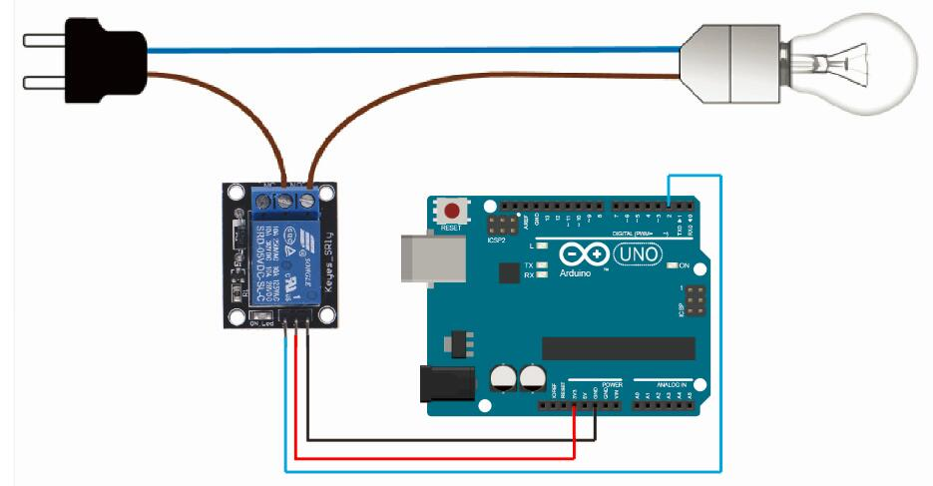The circuit connection diagram of the relay module with arduino is shown in figure. Where 12v of the power supply to the Vcc of the relay board. The GND to the GND of the relay board. The pin number 3 of the arduino to the IN1 of the relay board. Then the arduino is programmed to activate any one of the GPIO pins as per the request got from the webserver this activates the relay and drives the load.

Figure 4.15 connection of relay module with Node MCU 12e module

**4.7 LIQUID-CRYSTAL DISPLAY**

A liquid-crystal display (LCD) is a flat-panel display or other electronically modulated optical device that uses the light-modulating properties of liquid crystals. Liquid crystals do not emit light directly, instead using a backlight or reflector to produce images in color or monochrome .LCDs are available to display arbitrary images (as in a general-purpose computer display) or fixed images with low information content, which can be displayed or hidden, such as preset words, digits, and 7-segment displays, as in a digital clock. They use the same basic technology, except that arbitrary images are made up of a large number of small pixels, while other displays have larger elements.

LCDs are used in a wide range of applications including LCD televisions, computer monitors, instrument panels, aircraft cockpit displays, and indoor and outdoor signage. Small LCD screens are common in portable consumer devices such as digital cameras, watches, calculators, and mobile telephones, including smartphones. LCD screens are also used on consumer electronics products such as DVD players, video game devices and clocks. LCD screens have replaced heavy, bulky cathode ray tube (CRT) displays in nearly all applications. LCD screens are available in a wider range of screen sizes than CRT and plasma displays, with LCD screens available in sizes ranging from tiny digital watches to huge, big-screen television sets.

Since LCD screens do not use phosphors, they do not suffer image burn-in when a static image is displayed on a screen for a long time (e.g., the table frame for an aircraft schedule on an indoor sign). LCDs are, however, susceptible to image persistence. The LCD screen is more energy-efficient and can be disposed of more safely than a CRT can. Its low electrical power consumption enables it to be used in battery-powered electronic equipment more efficiently than CRTs can be.

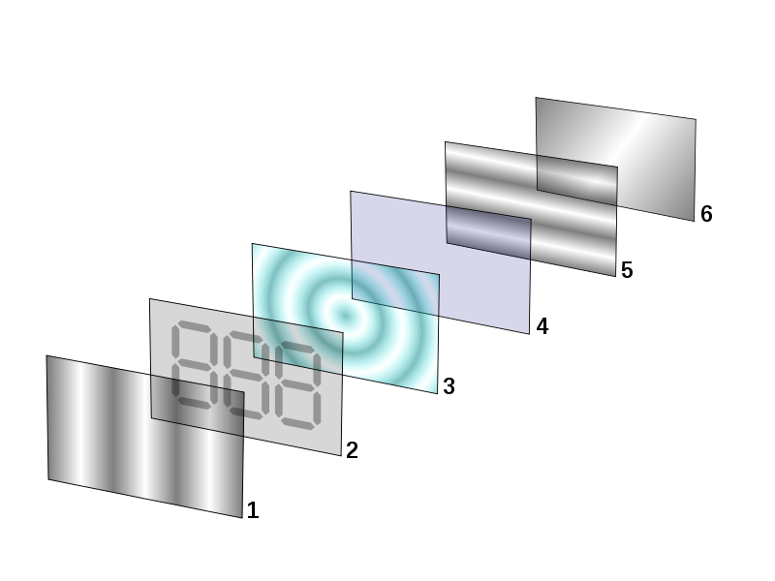

Figure 4.16 LCD layers

**4.7.1 LCD WORKING PRINCIPLE**

The principle behind the LCD’s is that when an electrical current is applied to the liquid crystal molecule, the molecule tends to untwist. This causes the angle of light which is passing through the molecule of the polarized glass and also cause a change in the angle of the top polarizing filter. As a result a little light is allowed to pass the polarized glass through a particular area of the LCD. Thus that particular area will become dark compared to other. The LCD works on the principle of blocking light. While constructing the LCD’s, a reflected mirror is arranged at the back. An electrode plane is made of indium-tin oxide which is kept on top and a polarized glass with a polarizing film is also added on the bottom of the device. The complete region of the LCD has to be enclosed by a common electrode and above it should be the liquid crystal matter.

Next comes to the second piece of glass with an electrode in the form of the rectangle on the bottom and, on top, another polarizing film. It must be considered that both the pieces are kept at right angles. When there is no current, the light passes through the front of the LCD it will be reflected by the mirror and bounced back. As the electrode is connected to a battery the current from it will cause the liquid crystals between the common-plane electrode and the electrode shaped like a rectangle to untwist. Thus the light is blocked from passing through. That particular rectangular area appears blank.

**4.7.2 16×2 LCD**

16×2 LCD is named so because; it has 16 Columns and 2 Rows. There are a lot of combinations available like, 8×1, 8×2, 10×2, 16×1, etc. but the most used one is the 16×2 LCD. So, it will have (16×2=32) 32 characters in total and each character will be made of 5×8 Pixel Dots. A Single character with all its Pixels is shown in the below picture.

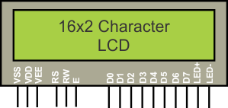

Figure 4.17 16x2 LCD

Now, we know that each character has (5×8=40) 40 Pixels and for 32 Characters we will have (32×40) 1280 Pixels. Further, the LCD should also be instructed about the Position of the Pixels. Hence it will be a hectic task to handle everything with the help of MCU, hence an Interface IC like HD44780is used, which is mounted on the backside of the LCD Module itself. The function of this IC is to get the Commands and Data from the MCU and process them to display meaningful information onto our LCD Screen.

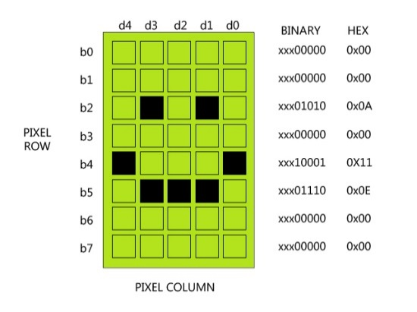

Figure 4.18 16x2 LCD Pixel

**4.7.3 16×2 LCD PIN CONFIGURATION**

**T**here are 16 pins in the LCD module, the pin configuration us given below by reading the table you can get a brief idea how to display a character. For displaying a character you should enable the enable pin (pin 6) by giving a pulse of 450ns, after enabling the pin6 you should select the register select pin (pin4) in write mode. To select the register select pin in write mode you have to make this pin high (RS=1), after selecting the register select you have to configure the R/W to write mode that is R/W should be low (R/W=0).

Follow these simple steps for displaying a character or data

* E=1; enable pin should be high
* RS=1; Register select should be high
* R/W=0; Read/Write pin should be low.

To send a command to the LCD just follows these steps:

* E=1; enable pin should be high
* RS=0; Register select should be low

|  |  |  |
| --- | --- | --- |
| **Pin No** | **Function** | **Name** |
| 1 | Ground (0V) | Ground |
| 2 | Supply voltage; 5V (4.7V – 5.3V) | Vcc |
| 3 | Contrast adjustment; through a variable resistor | VEE |
| 4 | Selects command register when low; and data register when high | Register Select |
| 5 | Low to write to the register; High to read from the register | Read/write |
| 6 | Sends data to data pins when a high to low pulse is given | Enable |
| 7 | 8-bit data pins | DB0 |
| 8 | DB1 |
| 9 | DB2 |
| 10 | DB3 |
| 11 | DB4 |
| 12 | DB5 |
| 13 | DB6 |
| 14 | DB7 |
| 15 | Backlight VCC (5V) | Led+ |
| 16 | Backlight Ground (0V) | Led- |

* R/W=1; Read/Write pin should be high.

Table 2: LCD pin Summery

A 16X2 LCD has two registers, namely, command and data. The register select is used to switch from one register to other. RS=0 for command register, whereas RS=1 for data register.

**Command Register:** The command register stores the command instructions given to the LCD. A command is an instruction given to LCD to do a predefined task like initializing it, clearing its screen, setting the cursor position, controlling display etc. Processing for commands happen in the command register.

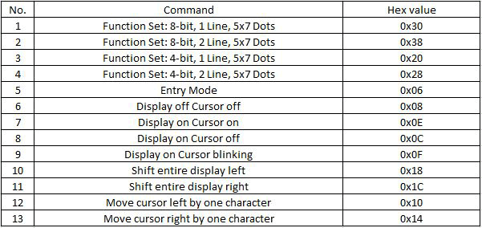**Data Register:**  The data register stores the data to be displayed on the LCD. The data is the ASCII value of the character to be displayed on the LCD. When we send data to LCD it goes to the data register and is processed there. When RS=1, data register is selected

Table 3: Important command codes for LCD

**4.7.4 ARDUINO INTERFACING**

We will use just 6 digital input pins from the Arduino Board. The LCD’s registers from D4 to D7 will be connected to Arduino’s digital pins from 4 to 7. The Enable pin will be connected to pin number 2 and the RS pin will be connected to pin number 1. The R/W pin will be connected to Ground and the Vo pin will be connected to the potentiometer.

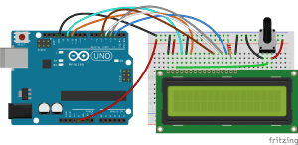

Figure 4.19: Connection Diagram

**4.8 Servo Motors**

A servo motor is a linear or rotary actuator that provides fast precision position control for closed-loop position control applications. Unlike large industrial motors, a servo motor is not used for continuous energy conversion.

**Types of Servo Motors**

Basically, servo motors are classified into AC and DC servo motors depending upon the nature of supply used for its operation. Brushed permanent magnet DC servo motors are used for simple applications owing to their cost, efficiency and simplicity. These are best suited for smaller applications. With the advancement of microprocessor and power transistor, AC servo motors are used more often due to their high accuracy control.

**DC Servo Motors**

A DC servo motor consists of a small DC motor, feedback potentiometer, gearbox, motor drive electronic circuit and electronic feedback control loop. It is more or less similar to the normal DC motor.The rotor consists of brush and shaft. A commutator and a rotor metal supporting frame are attached to the outside of the shaft and the armature winding is coiled in the rotor metal supporting frame. A brush is built with an armature coil that supplies the current to the commutator. At the back of the shaft, a detector is built into the rotor in order to detect the rotation speed. With this construction, it is simple to design a controller using simple circuitry because the torque is proportional to the amount of current flow through the armature. And also the instantaneous polarity of the control voltage decides the direction of torque developed by the motor. Types of DC servo motors include series motors, shunt control motor, split series motor, and permanent magnet shunt motor.

Working Principle of DC Servo Motor

A DC servo motor is an assembly of four major components, namely a DC motor, a position sensing device, a gear assembly, and a control circuit. The below figure shows the parts that consisting in RC servo motors in which small DC motor is employed for driving the loads at precise speed and position.

**CHAPTER 5**

**SOFTWARE DESCRIPTION**

**5.1 ARDUINO IDE**

The Arduino Integrated Development Environment - or Arduino Software (IDE) - contains a text editor for writing code, a message area, a text console, a toolbar with buttons for common functions and a series of menus. It connects to the Arduino and Genuino hardware to upload programs and communicate with them.

**5.2 SOFTWARE OVERVIEW**

Programs written using Arduino Software (IDE) are called sketches. These sketches are written in the text editor and are saved with the file extension .ino. The editor has features for cutting/pasting and for searching/replacing text. The message area gives feedback while saving and exporting and also displays errors. The console displays text output by the Arduino Software (IDE), including complete error messages and other information. The bottom righthand corner of the window displays the configured board and serial port. The toolbar buttons allow you to verify and upload programs, create, open, and save sketches, and open the serial monitor.Versions of the Arduino Software (IDE) prior to 1.0 saved sketches with the extension .pde. It is possible to open these files with version 1.0, you will be prompted to save the sketch with the .ino extension on save.

The following are the basic menu elements present in the Arduino IDE Software for coding, compiling and uploading a sketch on to an Arduino. Each menu has a different icon for easy identification. This icons are shown below along with there operations.

https://www.arduino.cc/en/uploads/Guide/IDE_VERIFY_File.jpg**Verify**  
Checks your code for errors compiling it.

https://www.arduino.cc/en/uploads/Guide/IDE_UPLOAD_File.jpg**Upload**  
Compiles your code and uploads it to the configured board. See [uploading](https://www.arduino.cc/en/Guide/Environment#uploading) below for details.

https://www.arduino.cc/en/uploads/Guide/IDE_NEW_File.jpg**New**  
Creates a new sketch.

https://www.arduino.cc/en/uploads/Guide/IDE_OPEN_File.jpg**Open**  
Presents a menu of all the sketches in your sketchbook. Clicking one will open it within the current window overwriting its content.

https://www.arduino.cc/en/uploads/Guide/IDE_SAVE_File.jpg**Save**  
Saves your sketch.

https://www.arduino.cc/en/uploads/Guide/IDE_SERMON_File.jpg**SerialMonitor**  
Opens the [serial monitor](https://www.arduino.cc/en/Guide/Environment#serialmonitor).

**5.1.1 PROGRAMMING**

When you open the Arduino program, you are opening the IDE. It is intentionally streamlined to keep things as simple and straightforward as possible. When you save a file in Arduino, the file is called a sketch – a sketch is where you save the computer code you have written.

The coding language that Arduino uses is very much like C++ (“see plus plus”), which is a common language in the world of computing. The code you learn to write for Arduino will be very similar to the code you write in any other computer language – all the basic concepts remain the same – it is just a matter of 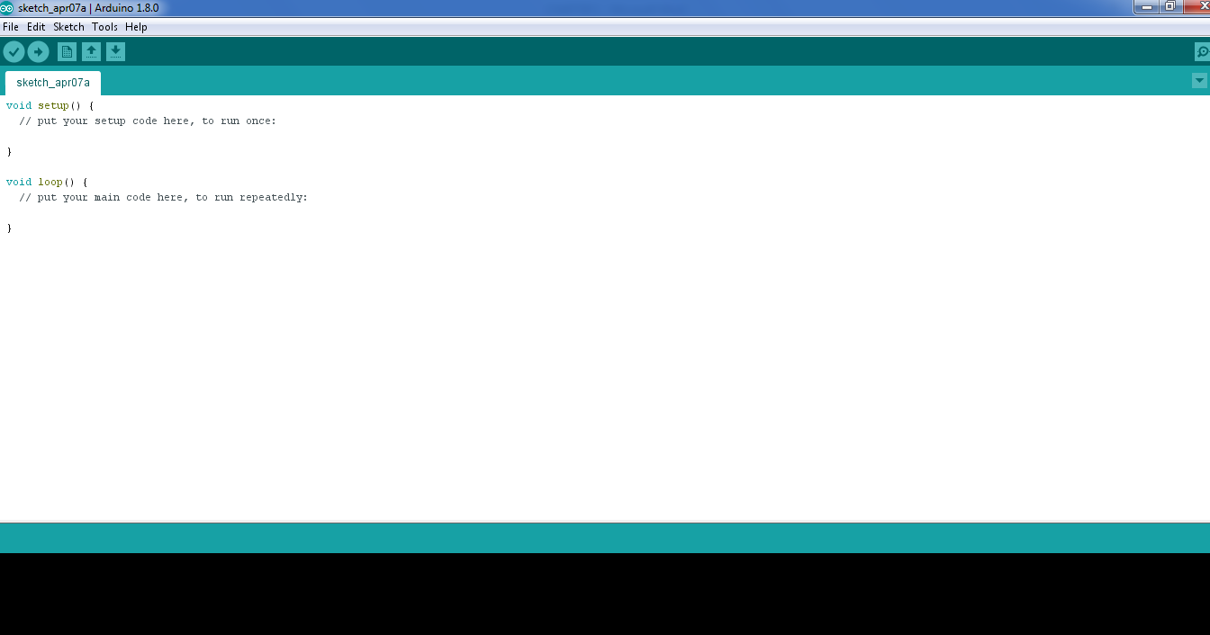learning a new dialect should you pursue other programming languages.

Figure 5.1 programming window

The code you write is “human readable”, that is, it will make sense to you (sometimes), and will be organized for a human to follow. Part of the job of the IDE is to take the human readable code and translate it into machine-readable code to be executed by the Arduino. This process is called compiling.

The process of compiling is seamless to the user. All you have to do is press a button. If you have errors in your computer code, the compiler will display an error message at the bottom of the IDE and highlight the line of code that seems to be the issue. The error message is meant to help you identify what you might have done wrong – sometimes the message is very explicit, like saying, “Hey – you forget a semicolon”, sometimes the error message is vague.Why be concerned with a semicolon you ask? A semicolon is part of the Arduino language syntax, the rules that govern how the code is written. It is like grammar in writing. Say for example we didn’t use periods when we wrote – everyone would have a heck of a time trying to figure out when sentences started and ended. Or if we didn’t employ the comma, how would we convey a dramatic pause to the reader?And let me tell you, if you ever had an English teacher with an overactive red pen, the compiler is ten times worse. In fact – your programs WILL NOT compile without perfect syntax. This might drive you crazy at first because it is very natural to forget syntax. As you gain experience programming you will learn to be assiduous about coding grammar.

**CHAPTER 5**

**CONCLUSION**

The Proposed soil Moisture Controlled irrigation system has been designed and tested successfully. It has been developed by integrated features of all the hardware components used. The system has been tested to function automatically. The moisture sensors measure the moisture level (water content) of the different plants. If the moisture level goes below the desired and limited level, the moisture sensor sends the signal to the Arduino board which triggers the Water Pump to turn ON and supply the water to respective plant. When the desired moisture level is reached, the system halts on its own and the water Pump is turned OFF. Thus, the functionality of the entire system has been tested thoroughly and it is said to function successfully

**REFERENCES**

1. R. Nageswara Rao; B. Sridhar, Year: 2018, “IoT based smart crop-field monitoring and automation irrigation system”,International Conference on Inventive Systems and Control ,pp: 478 – 483.
2. S. Vaishali ; S. Suraj ; G. Vignesh ; S. Dhivya ; S. Udhayakumar, Year: 2017, “ Mobile integrated smart irrigation management and monitoring system using IOT”, International Conference on Communication and Signal Processing ,pp: 2164 – 2167.
3. Shweta B. Saraf ; Dhanashri H. Gawali, Year: 2017, “ IoT based smart irrigation monitoring and controlling system”,IEEE International Conference on Recent Trends in Electronics, Information & Communication Technology ,pp: 815 – 819.
4. Pradorn Sureephong ; Patcharapong Wiangnak ; Santichai Wicha, Year: 2017 “The comparison of soil sensors for integrated creation of IOT-based Wetting front detector (WFD) with an efficient irrigation system to support precision farming”, International Conference on Digital Arts, Media and Technology ,pp: 132 – 135.
5. Kamel Ammour, Year: 2018 “Factory automation and irrigation control in an IoT environment”,Learning and Technology Conference ,pp: 120 – 128.
6. M. Mahalakshmi ; S. Priyanka ; S. P. Rajaram ; R. Rajapriya, Year: 2018,“ Distant Monitoring and Controlling of Solar Driven Irrigation System through IoT”,National Power Engineering Conference, pp: 1 5.
7. M. Newlin Rajkumar ; S. Abinaya ; V. Venkatesa Kumar, Year: 2017, “Intelligent irrigation system An IOT based approach”, International Conference on Innovations in Green Energy and Healthcare Technologies ,pp: 1 – 5.
8. Amogh Jayaraj Rau ; Jairam Sankar ; Ashok R Mohan ; Deepti Das Krishna ;Jimson Mathew, Year: 2017,“ IoT based smart irrigation system and nutrient detection with disease analysis”, IEEE Region 10 Symposium ,pp: 1 – 4.
9. M Monica ; B. Yeshika ; G.S Abhishek ; H.A Sanjay ; Sankar Dasiga , Year: 2017,“IoT based control and automation of smart irrigation system: An automated irrigation system using sensors, GSM, Bluetooth and cloud technology”, International Conference on Recent Innovations in Signal processing and Embedded Systems ,pp: 601 – 607.
10. Kiranmai Pernapati, Year: 2018, “IoT Based Low Cost Smart Irrigation System”, International Conference on Inventive Communication and Computational Technologies pp: 1312 – 1315.